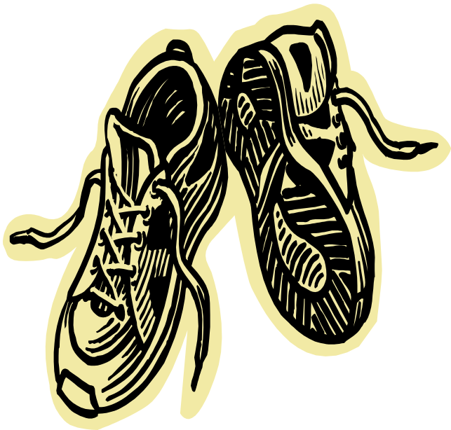
April
Newsletter

Well done to the
Hull and Brighton Marathon ladies!

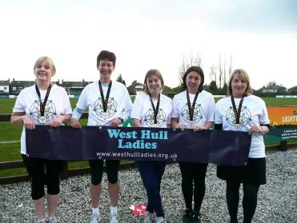

Amanda, Katy and Geri, Verity and Sally, Ann and Yendis

WEST HULL LADIES RRC
COMMITTEE MEETING

There was no West Hull Ladies Committee Meeting

this month, due to the AGM

Please note, however, that ladies are warmly invited to come to the next meeting to gather some feedback on the Hull Marathon.

The meeting will be 30th April, after training

We feel it is important to send a club feedback to the organizers with regards to their first marathon, and having input from all ladies who attended the marathon would be beneficial, as I think most of us experienced problems, whether as a runner or helper. However, if you are unable to attend this meeting, please email the club with your concerns and they will be entered into the discussion.

I believe this could be a great event for West Hull Ladies, as it encompasses different race types allowing for different challenges and it would be a shame to see it not run smoothly in the future.

Hope to see you there,

Jo – Club Chair

Marathon recovery

Marathon recovery begins the minute you cross the finish line. Keep walking at least 10 minutes after you cross the finish line to allow your body to return to its resting state gradually. Get your medal, take your photos, pick up your gear and keep walking. It will allow your heart rate and blood flow to return to its normal state as well as reduce the risk of blood pooling in your legs which can cause fainting. Get up and walk around 10 to 15 minutes every few hours for the rest of the day.

Refuel depleted muscles as soon as possible with a meal that includes carbohydrates, protein and sodium. Fuel is most efficiently absorbed in the first 30 to 60 minutes post-race. A peanut butter and jam sandwich, banana and sports drink is one example. If you struggle with eating post-race, try a liquid recovery drink. Recovery drinks are formulated with everything you need to refuel your body--carbohydrates, protein, electrolytes and fluid.

The stress of running a marathon can depress your immune system, leaving you susceptible to colds, flu and other upper respiratory tract infections in the days immediately following the race. Self-care is the best way to reduce your risk of contracting a virus, so make sure you get plenty of sleep, eat well-balanced meals and drink lots of water.

A general lack of energy in the week following marathon is perfectly usual. Try to eat meals comprising 50-60 per cent carbohydrates to replenish your glycogen reserves, and foods rich in protein to assist your body in repairing muscle and tissue. Indulge any cravings you might have – these could be your body’s way of telling you what it needs. Scientific research also indicates that many marathon runners lose around 3mg of iron per day for up to five days after the marathon, so eat foods rich in iron: meat, spinach, beans, peaches, parsley and peas during your post-marathon week. To promote iron absorption, drink orange juice or consume other rich sources of vitamin C with your meals.
Some runners complain of weight gain immediately after a marathon. This is most likely due to water retention as your muscles repair and rebuild. Don’t be tempted to start (or resume) any weight-loss regime during this time – your body requires a full complement of nutrients to recover from the stress of the race. Of course, if you are still gaining weight after your first recovery week, you might want to consider adjusting your calorie intake to suit your new activity levels.

Tapering in Reverse
Just as you tapered off with decreasing weekly mileage in the weeks just prior to the marathon you need to do the opposite after the race. Here is a typical post race schedule:
Week 1:
Mon | Tue | Wed | Thu | Fri | Sat | Sun
Walk | Walk | 3M | Walk | Rest | 4M | Walk
Week 2:
Mon | Tue | Wed | Thu | Fri | Sat | Sun
3M | Rest | 5M | Walk | Rest | 6M | Walk

Hornsea Third

Susan

Barbara and I are hoping to run a Half Marathon this year so as a "stepping stone" took part in the Hornsea Harriers Third of a Marathon on Sunday, 1st April. All the way through was the perfect running conditions, bright and sunny for clear views to distract when tired but with a slight breeze to cool us, however the first 4 miles was quite a strong headwind! Whilst taking on pre-race liquids at my car we were greeted by Sandra who had driven with vehicle loaded with her bike announcing she was doing reccie on the route and to support us, kindly loading the panniers with our energy drinks for the 5 mile post!

The route was along single track roads in the Great Hatfield, Sigglesthorne and Rise area. It was idyllic. Someone had told me slight undulations. Undulations! I never realised how many the Holderness countryside had - we counted 8 steady climbs! But never walked once :)

At the 5 mile true to her word Sandra greeted us with drinks with lots of encouragement and tips and taking the sneaky photo too! Told us we were looking strong and on we ran. By 7 miles with lots of "undulations" behind us we started to feel the heat and especially knowing we were near the end. Sandra joined us about then riding alongside with lots of end of race encouragement then cycling ahead to greet us at the finish line.

In last quarter of mile we found some energy from somewhere sprinting over the Finish Line with Sandra beaming at us. What a welcome sight she was. GREAT DAY!!!!!

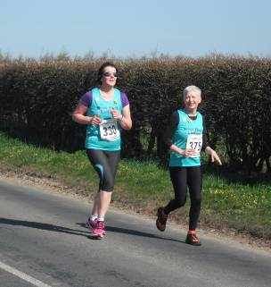
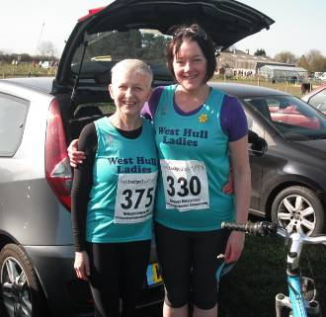
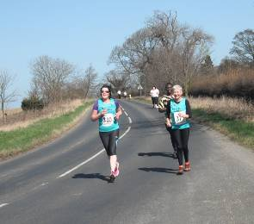
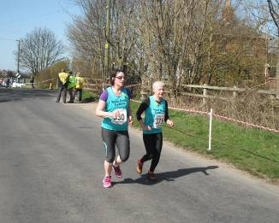

Hull Marathon

Amanda

My third marathon after London in 2000 (3:58) and Robin Hood (Nottingham) in 2008 (3:33)

My aim was sub 3hrs 15mins. Why? Because this is Championship entry to the London Marathon for females. So I found a suitably tough 16 week training schedule and managed most of it. The East Hull 20 in 2:27 said I may have a chance if all goes well. The last week of tapering is always weird, you feel like you should be doing more and end up on the start line thinking “can I still run?”. I prepared as best I could, good food, lots of sleep and even getting up at 5:30am to get used to the early start on the day.

The day arrived with good conditions for running, cool, a light wind and light rain. I was glad when we were off, tripping over very slow runners who decided to start on the front line! After a couple of miles I was settling down and it was good to reach West Hull Ladies club water station. I dropped my hat and gloves and grabbed a cup splashing water all over Jo (oops) and carried on. 4 miles came just after Walton street, and I was a little up on my pacing. Next 4 miles got me to the Humber Bridge with a perfect pace (7:15) and Neil (husband) handed me a gel. I was really amazed at how many cheers of support I was getting from people who knew me and lots of extra cheers as I was currently 1st lady!!!

Over the bridge and a minute down, as expected, which meant I arrived at 12 miles in 1hr 27mins which was spot on. Unfortunately over the next 4 miles the pace started to bite and at 16 miles my pace was down to 7:25 - I was going down fast ☹. I had lost my 1st lady status at about 13.5M - I enjoyed it whilst I could. Got a stitch on the flyover on Hessle Rd and walked for about a minute then Neil was there at 17 miles and I told him I wanted to cry and give up which he was a bit surprised about as my time was still good – but I knew how my body was feeling. I started to plod. I was thirsty but no drinks station until nearly at The Deep (6 miles from the previous water station). Now, along the water front which seemed to go on a long way before turning back. Once off the river we were nearly there so I just kept turning the legs. Lots of support through town then the finish appeared! I slumped on the poor chap who unclipped my chip, drank my recovery drink then queued for a calf and foot massage - which was fantastic.

I soon got over the disappointment of not managing 3:15 and am pleased with 3hrs 25mins, a good PB. Will I try for it again? Almost certainly! (Madness)

Hull Marathon? It’s not a bad route. The long drag up Boothferry Rd and the bridge slows you down. The cobbles around the marina were hard going, over half a mile of them in total and the off-road bit round Pickering Park is not fast either. Plenty of twists and switch backs on the river to slow you down too. However, it could be a PB route as the majority is flat. Shame it was not better weather for the views on the Humber Bridge. On a clear day you can see the bridge from the far end of the river. The organisation needs some working on and it may be short! Hopefully a lot of improvement for next year. The support from the Hull people was really great. I was quite touched by the number of times a chap said “come on love, you are doing well”. With just a mile to go, Whitefriargate precinct had a great crowd urging us on and the finish funnel was packed with cheerers.

A great day for West Hull Ladies: 5 marathon runners, 8 team runners, 12 Club water station helpers, 1 fun runner with kids, 2 marshals and Susan supporting loudly.
Geri

Katy and I decided to go to the event together . Katy picked me up and we travelled chatting excitedly. We had decided to run together as I am not very good at the start of a race, it takes me a while to settle in and Katy likes my sustainability (keeping her motivated till the end). We always agree that if one is struggling the other must go so on that basis we made our way to the start line.

We were off running comfortably, and the weather was cool which was nice. Saw a few familiar faces in the crowd. Lovely to see the girls in West Park, who gave us a fabulous cheer, (sorry for soaking you all). Ran up Anlaby Road, Boothferry where we decided to put our music in. The next bit I was dreading - the Bridge. I had spoken to Katy about this and she said I’d be fine and after a quick pee stop off we trotted. How right Katy was, because the bridge was ok.

On the return journey I had started to pull away from Katy. I could see she was struggling, and I asked her if she was ok but she had cramp. We carried on slowly but had to stop. I could feel my legs tighten up when I set off again. We decided to get over the bridge and have a drink and see how Katy felt. I made it to the station where I had a gel and a drink. Katy arrived a few minutes later and told me to carry on without her as she still had cramp. After a bit of conversing I left Katy (I felt awful) and carried on the long lonely journey - I missed my buddy. I had no watch didn’t see any markers and kept thinking what the hell am I doing.

Finally approaching town centre, and I kept thinking this can’t be far now, but believe me, the run up on the front of Victoria Dock was horrendous. I saw Verity and Sally pass me by. I just kept thinking of my dad throughout the run as he had been admitted into hospital the day before and this kept me going.

Back over Millennium Bridge and the end was closing in - down Whitefriargate, King Edward Street, Albion Street where I stopped to have a walk. My head and body felt fine but my legs did not want to start again. Approaching Bond Street I heard “Hey Geri” - I looked up and saw my mate Susan. She told me that I had nearly finished and that she had been on nights but wanted to cheer us in (mad I know). I told her I was so tired and couldn’t run anymore. She told me to start running and she would run beside me in her jeans and boots (Ha Ha ) I started to run and caught sight of the finish line. I could hear people cheering as I got a second wind and sprinted over the line.

Thank goodness for this and thank goodness for Susan what a star couldn’t do it without you xx

Thanks Katy you always had faith in me and thanks West Hull Ladies for making this possible x

Bring on London next year because, I am entering.

Lynda

Thanks for the mention & yup 1st Marathon!..Felt so good too unbelievably! a stitch threatened at around 22 miles but just pressed it & vanished (good advice from Stella re stitches) & undoubtedly tired legs in last miles (never run that far), even managed a sprint at the end showing off, Big mistake, the cramp when I stopped was shocking! straight on the massage table, alongside Amanda for lovely treatment & felt like I'd eaten a curry the night before from the Gels, Ouch...

Well done marathon girls you should all be proud of yourselves, brilliant day X
Sally

I really enjoyed my first marathon, and was so pleased just to finish having hurt my left knee 2 weeks beforehand! Once again I’d like to thank all the ladies at WHL. I first came the club on a dark cold Friday night at the end of January, having signed up for the Hull Marathon the previous November, and realising that I might actually need to begin some training!! The support and advice from the club helped me through several colds and when injury reared its head – I’m also grateful to Debbie for making the long Sunday runs fun, and go so quickly! I’m going to have to take a few weeks off to recover from surgery (not running related!) but I’ve put my name down to buddy at the end of June, and I think I might also have said to LouiseW that I’d run the Major Stone half marathon after a couple of beers last Friday, so I’ll definitely be back soon!
Sal x

Maria

My first time as a helper in a race and have to say I enjoyed it thoroughly. It was great to be on the other side but somehow still felt the pressure as wanted to make sure that if anyone stopped at me to get water then water they got to drink and not all over them!!
I have to agree with Jo that as a water station we did a brilliant job, we were all very encouraging and very cheerful. For the news letter I have attached my thank you for being voted 3rd most improved, still quite shocked but extremely pleased.
The best way I can describe West Hull Ladies is by saying that WHL is THE CLUB

Annette
Our water station seemed to go well. We had a lot of people to help and it didn't take long to tidy up afterwards. The boys were very pleased when people took water from them. I then let them play in the playground for about an hour. They were both asleep by 7pm so a very successful day in all!

Jo

WHL really did the biz at the West Park water station, thought we were really slick. The kids were fab, Jess wishing everyone Happy Easter and the runners getting loads of encouragement.

If I were running, I'd have thought it a brilliant station!

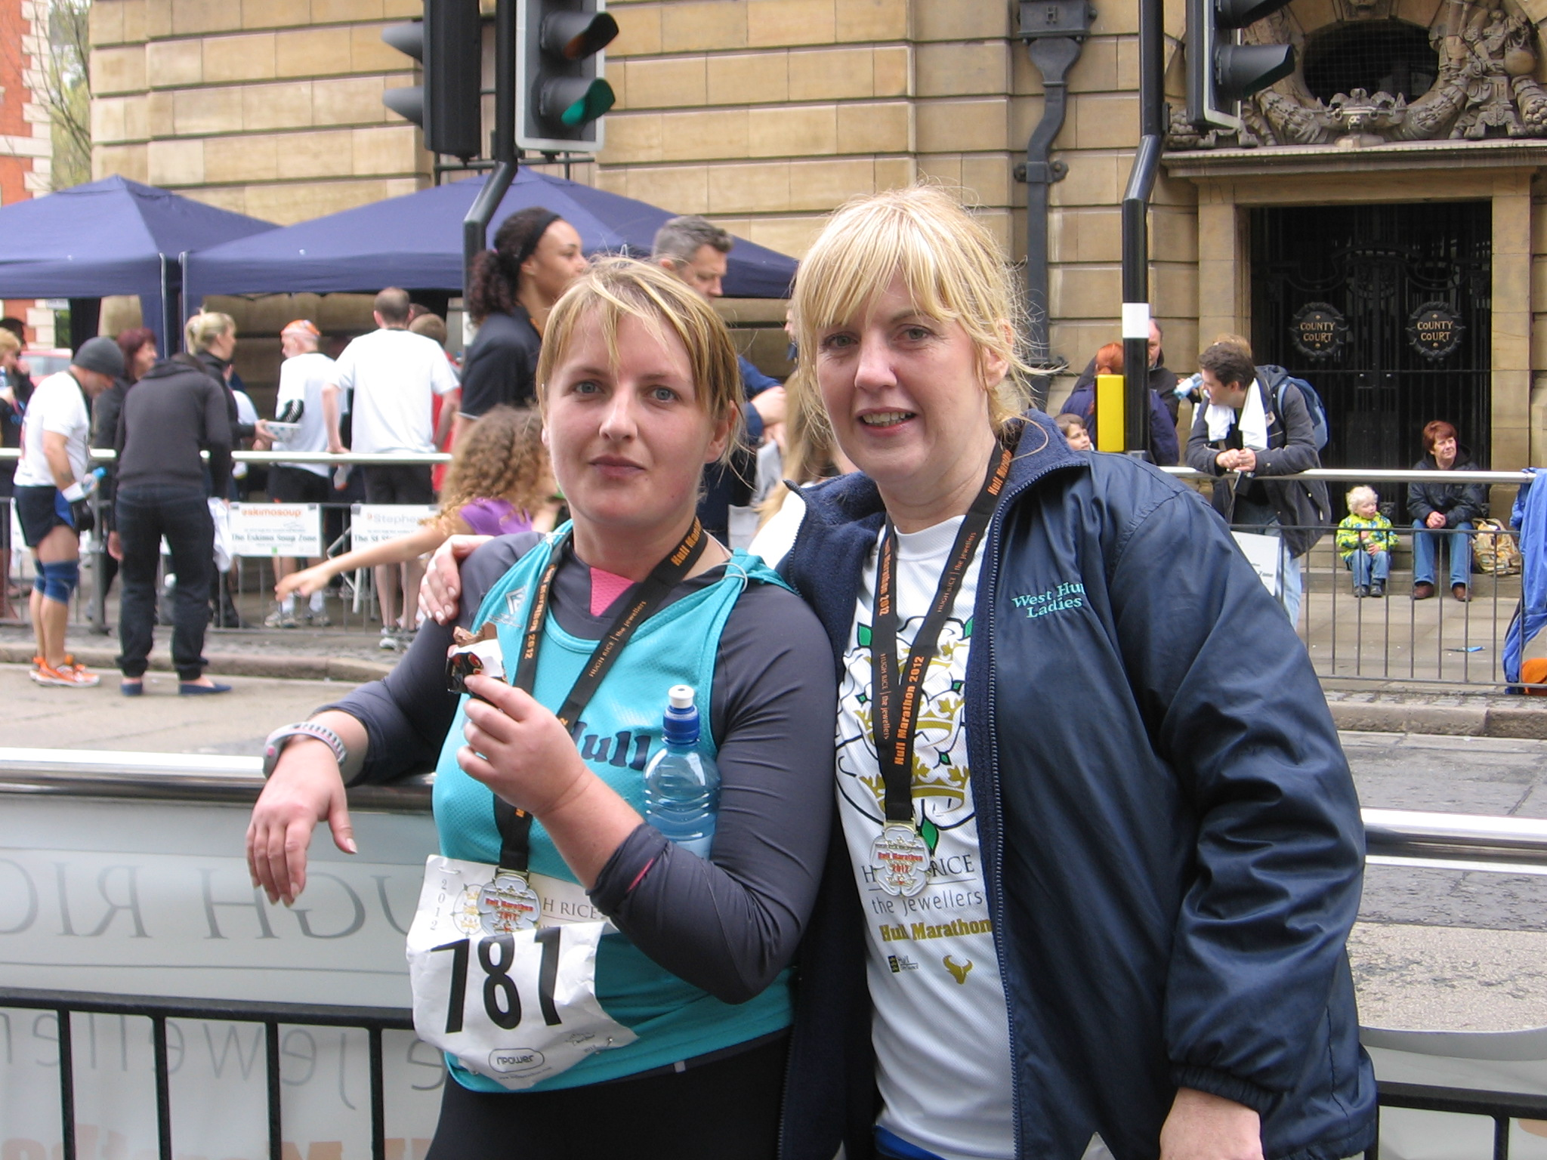
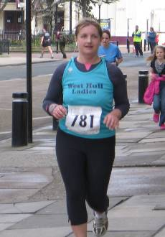
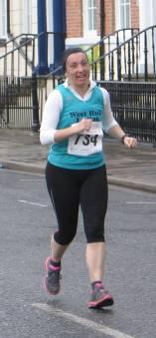
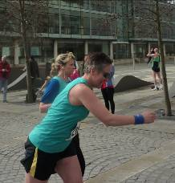
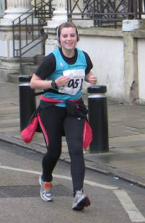
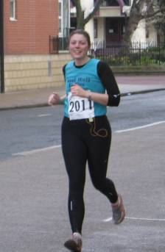
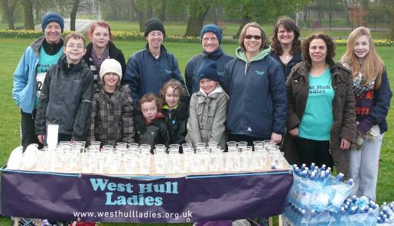
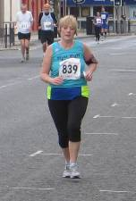
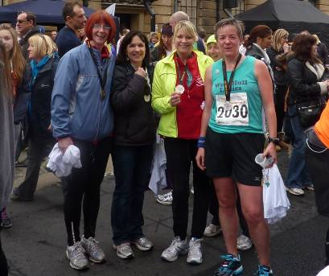

Brighton Marathon

Ann

My first marathon! The training had gone well – I’d read every magazine article, and been inspired by countless tales from WHL, Paula and other famous runners, as well as the not-so-famous. I probably over-did the carb loading by loading up on everything, though!

My first task was to overcome my fears from having completed the final leg of the Hull marathon relay. Whilst I enjoyed speeding past the 26.2 milers, I was acutely aware of just how many people were struggling in these last 6 miles, and I spent a couple of days worrying about this, but had to remember that I’d past far more people who weren’t.

It was a bit like this on race day. The start of the race was good – great organisation, a big race, but very compact, with long toilet queues which actually went down very quickly, and only 10 minutes from the gun to crossing the line and starting to run.

Yes, it was definitely ‘undulating’, but I was ready for this, and the hills weren’t as demanding as I’d expected.

The crowds were fabulous – almost throughout the route, even when we ran through a ‘deserted’ power station, still people gathered to cheer us on! Wearing your name on a charity vest is wonderful – I lost count how many cheered me on by name, some almost as if they knew me. It really helped, in fact, it made me smile when we ran down a quieter street, and only then did the weary stop to stretch, when ‘no one was looking’! Hats off to the Hull marathon ladies, who didn’t have this support – hopefully this will grow in Hull over time ...?

I wondered about ‘the wall’. I think I’d experienced this in a training run, so I knew how rotten it would be. I started seeing others really struggling, stretching, speaking to medics, and realised the same thing was happening as at Hull the week before – it was knocking my confidence. I decided not to look at them at all, but to look instead at the runners who were, well running, and this helped.

So too did the best piece of advice I read in a magazine. It said to dedicate each of the last few miles to particular people who had supported me in my preparation. This was really useful, so, for example, mile 21 was spent imagining Anders, my son, running alongside me, and urging me to keep running, like I do for him at Parkrun. The last mile was dedicated to my dad, who really helped me with fundraising, and came down especially for the race. Thanks, Dad!

I didn’t hit the wall until I finished, when I did feel pretty horrible at first, but the organisers force you to keep walking – medal first, then onto T-shirts, then to the lorries to collect your bag and so on. This was good, but my visit to the charity tent was fab – NSPCC had about 16 massage tables, with 2 therapists at each one – one per leg! I felt a lot better after my post-race massage and a cup of tea, and could face my peanut butter bagel and malt loaf I’d prepared earlier, a quick change into some warmer clothes, and then off to meet up with my family.

So I am now a marathon runner – it was a really wonderful experience, and I can honestly say I am itching to do the next ...!

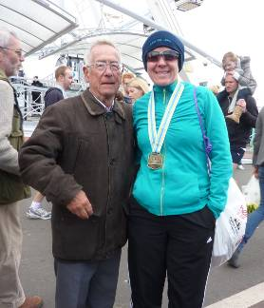
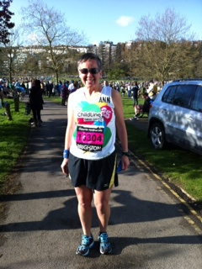
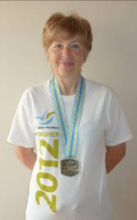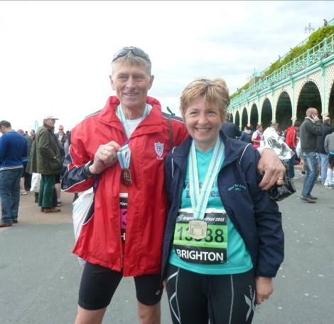

West Hull Ladies Y-NOTS

Jill: Fabulous runs by you, Verity, Sally, Katy and Geri!...wow!
Our team run WHL Y-NOTS went really well...and I'm hurting after 10k...!!!
Hope there will be other opportunities to do some team running as we really enjoyed getting together to train...and eat lots of buns!
Cheers Jill

Anna: Fab day - loved being able to take part- really enjoyed myself. Complete hats off to all of you who even thought about training and running the whole thing- wow!.
Great to see you all- and thanks so much to my relay team who were wonderful.
Cheers Anna

Ruth:I enjoyed my bit of the marathon relay. Setting aside the pressure of not letting the team down, I found it less stressful than a normal race and thoroughly enjoyed the social side, chatting to other member's families at change-over points etc. x

LouiseW: I really enjoyed the event and it has made me feel a lot more positive about racing... I might even sign up for something else later on in the year!

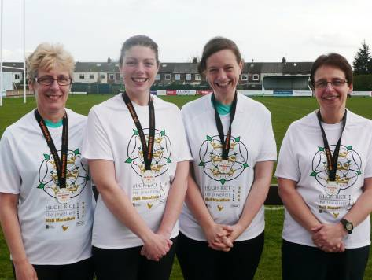

Virgin London Marathon

Sandra, Sharon and Gill

STOP PRESS!

Our ladies have finished!

Sandra 4:55:06
Sharon 5:35:32
Gill 5:35:32

Great effort – we’ll look forward to reading about your London experience in next month’s newsletter!

For sale ...

Susan

I recently bought a new pair of running shoes which are extremely comfortable but unfortunately have found when I run, they are too big for me. I have only worn them about 6 times.
They are Asics Foundation running shoes suitable for the runner who "over pronates". Size 6.5 wider fit.
I am offering them to a good home if any of WHL ladies are in need of another pair of running shoes.
They cost me £84, happy to sell them for half that
Regards
Susan x

Poet’s Corner ...

Maria

Monday was sports day at school
On the coach we go away
Tennis, football, netball and volley ball
Were the order of the day
To my horror and dismay
NETBALL I was told to play
Tried tennis, football and volley ball
All ended in the same way
To a chorus of girls shouting
“Maria get out of the way”
Running was the next event
Hurdles my first trial
Knocked every single one down
The chorus of girls shouted
“Maria just give up”
Now that I am much older
I joined a fantastic club
This time the girls are shouting
“Maria keep the pace up”
I end this sort of poem
With a very big smile
Thank you West Hull Ladies
For making me so proud
Racing and Running Events

Date | Event | Distance | Fee | Entry / website
April
28th 8.00 | The Woldsman | 50 ml | £15 | http://www.ldwa.org.uk/EastYorkshire/E/8580/the-woldsman.html
May
6th 9.00 | Nth Lincs Half | Half marathon | £22 | www.northlincshalf.com
13th 11.15 | Beverley 10k | 10k | £12 | www.beverleyac.com
27th 9.00 | Sheffield Half | Half marathon | £23 | http://www.runbritain.com/
26th 10.30 | Ultra Running Made ultra simple - training | 4-5 hours | £25 | www.gobeyondultra.co.uk  training for October 6th
27th 1100 | Driffield Mucky Duck | 8.5 miles | £10 | www.driffieldstriders.org.uk
June
3rd 9.00 | Jane Tomlinson Hull | 10k | £24 | www.runforall.com
4th 10.00 | Sting in the Tail, Caistor | 10k | £8 | www.caistorrunningclub.com  (Postal only, deadline 18th May)
10th | Goole Riverbank Challenge | 1/3 marathon | £9 | Entry form
24th May | Humber Bridge Half | ½ marathon | £20 | www.humberhalf.org.uk
30th 8.30 | Sterne Encounter | 23.5 miles | £8/£10 | Entry form
July
6th 7.30 | Walkington 10k | 10k | £10 | www.beverleyac.com
7th from 4 am! | Lyke Wake Walks | 42 miles | £12/£15 | Details
8th 9.00 | Jane Tomlinson Leeds | 10k | £24 | www.runforall.com
8th 9.35 | British London 10k | 10k | £50 (guaranteed) | Ballot entry for £32.50  www.thebritish10klondon.co.uk/
8th 2.00 | Kilburn Feast | 7ml | £10 | www.realbuzzbritain.com
8th 11.00 | Grimsby Sea Wall | 5 miles | £9 | http://www.woldsvets.co.uk/
22nd | Harrogate | 10k |  | www.harrogateharriers.co.uk
August
5th 9.00 | Jane Tomlinson York | 10k | £24 | www.runforall.com
19th 11.00 | Escrick 10k | 10k | £9 | www.escrick10k.co.uk
25th 8.00 | Smugglers Trod | 17 or 25 ml | £8 | http://www.ldwa.org.uk/YorkshireCoast/W/1416/2012-smugglers-trod-entry-form.html

September
1st 11.00 | 30th Lincs Wolds | 10 miles | £11 | http://www.woldsvets.co.uk/
9th 10.00 | Major Stone | 1/2 marathon | £14 | www.easthullharriers.com
October
6th 9.00 | Round Ripon Ultra | 35 miles | £39 or free | www.gobeyondultra.co.uk  Postal entries only see May 26th

** Dates/times are subject to change **
Keep checking the website for new races and updates: www.westhullladies.org.uk/races.htm Verity, Racing Officer

Hull or Brighton for a marathon?

- In Hull you get a technical T-shirt
- In Brighton you get sun
- In Hull you get cheered by name because people actually do know you and aren’t just reading your vest
- In Brighton you get hair conditioner in your goodie bag??
- In Hull you get a Snickers
- In Hull the hardest miles are through deserted docks
- In Brighton the hardest miles are through a deserted power station
- In Hull some runners didn’t even get a time
- In Brighton some runners didn’t even get a time either!
- In Hull you get to run past a marina and a pier
- In Brighton you get to run past two marinas and two piers, although one is a burnt ruin
- In Hull it takes just a few minutes to drive home
- In Brighton you it takes about 6 hours
- In Hull some faster ladies have a darn good chance of being first without having to come from Kenya!
- In Brighton there are very few worries about being last, unless you want to moonwalk it

Who wins? Run them both, and then you decide!
NOTE: Club Vests must be worn at any races you enter
under the West Hull Ladies running club name.

Clubwear
PRICES:
Vest | £16.00 | All items are ordered on request and must  be paid for at time of ordering. To place an  order please get in touch via West  Hull Ladies e-mail and mark your emails  for the attention of Geri.
T- shirt | £16.50
Hoodie | £14.00
Jacket | £32



New Club Jacket available in three sizes: small, extra small, and junior (large fitting). If you would like to purchase one please send a cheque for £32 to Victoria Voase, Treasurer, and state on the back of your cheque your name and that the cheque is for a jacket.

Becca

Running Library

You can borrow any of these books – they are upstairs near the toilets at the end of the corridor
Book List:
- The Runner's Diet (Runners World), Madelyn H. Fernstrom
- Paula My Story So Far, Paula Radcliffe
- The Runner's Handbook, Bob Glover
- The Competitive Runner's Handbook, Bob Glover & Shelly Lynn Glover
- Marathon Running For Mortals, John Bingham

- Lore of Running,

Running Magazines: These are available to borrow by emailing the club website.
Mark your email for the attention of Becca.

